National University of Computer and Emerging Sciences



Assignment 1

Object Oriented Programming Lab

|  |  |
| --- | --- |
| Name | Muhammad Zain |
| Roll No. | 19F-0228 |
| Course INSTRUCTOR | Sir Danish Shehzad |
| Lab INSTRUCTOR | Sir Mughees Ismail |
| Semester | Spring 2020 |

# Task 1;

## Source code;

#include<iostream>

#include<string>

using namespace std;

struct student {

string Name;

double Cnic;

string Gender;

double Cgpa;

};

struct section {

student*array;

string SectionName;

string ClassTeacher;

};

int main()

{int index; section E;int n;

E.array = new student[40];

int choice; int numberOfSections;

cout << "Press 1 to Change Name" << endl;

cout << "Press 2 to Change Cnic " << endl;

cout << "Press 3 to whole entries of students" << endl;

cout << "Press 4 to exit" << endl;

cin >> choice;

if (choice == 1)

{

cout << "iNPUT THE NUMBER OF STUDENT" << endl;

cin >> index;

cin >> E.array[index].Name;

}

if (choice == 2)

{

cout << "iNPUT THE NUMBER OF a STUDENT" << endl;

cin >> index;

cin >> E.array[index].Cnic;

}

if (choice == 3)

{cout << "Input the numbers of sections you want to enter" << endl;

cin >> numberOfSections;

cout << "enter number of students of whom data you want to enter" << endl;

cin >> n;

cout << endl << "Enter your Name CNic Cgpa And Gender Respectively" << endl;

for (int i = 0; i < numberOfSections; i++)

{

for (int numberofStudents = 0; numberofStudents < n; numberofStudents++)

{

if (numberofStudents >= 40)

{

++numberOfSections;

}

else if (numberofStudents < 40)

{

cin >> E.array[numberofStudents].Name;

cin >> E.array[numberofStudents].Cnic;

cin >> E.array[numberofStudents].Cgpa;

cin >> E.array[numberofStudents].Gender;

}

}

}

for (int i = 0; i < numberOfSections; i++)

{

for (int numberofStudents = 0; numberofStudents < n; numberofStudents++)

{

cout << E.array[numberofStudents].Name;

cout << E.array[numberofStudents].Cnic;

cout << E.array[numberofStudents].Cgpa;

cout << E.array[numberofStudents].Gender;

}

}

}

if (choice == 4)

{

exit;

}

system("pause>0");

}

## SNIP;

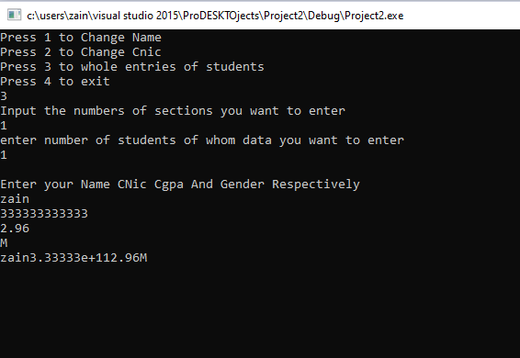

# Task 2;

## Source code;

#include<iostream>

#include<string>

using namespace std;

struct circle {

float radius;

};

struct triangle {

float height;

float base;

};

struct rectangle {

float length;

float width;

};

circle = cri;

rectangle = tri;

triangle = tri;

int main()

{

int choice;

cout << "Press 1 to find the Area of circle" << endl;

cout << "Press 2 to find the Area of triangle" << endl;

cout << "Press 3 tofind the Area of triangle" << endl;

cin >> choice;

if (choice==1)

{

double radius, circle;

cout << "please input the radius of circle" << endl;

cin >> radius;

circle = 3.14*(radius*radius);

cout << "The area of circle is " << circle;

}

if (choice == 2)

{

double rectangle, length, height;

cout << "please input the length of rectangle " << endl;

cin >> length;

cout << "please input the height of rectangle " << endl;

cin >> height;

rectangle = length*height;

cout << "The area of rectangle is " << rectangle;

}

if (choice == 3)

{

double triangle, base, height;

cout << "please input the length of rectangle " << endl;

cin >> base;

cout << "please input the height of rectangle " << endl;

cin >> height;

triangle = (base*height) / 2;

cout << "The area of triangle is " << triangle;

}

}